A **label**is used to give information about a product. It is usually put on the back of most products. By reading the labels, people will know whether the product is good to consume or not. Many countries require that packaged food products have labels containing nutrition facts/information.

**The Purpose of Labels.**

They are used to give information about the products.

**The social functions of food, drink, and medicine labels**

1.      To choose food/beverage/medicine which is suitable and safe.  
2.      To avoid negative effects of food/beverage/medicine.  
3.      To get the best result of medication.

**A Label Contains/Generic Structure of Labels**

1.      Name of the product,  
2.      Name of the brand,  
3.      Description of the product,  
4.      The ingredients/the contents,  
5.      The nutrition facts,  
6.      Suggested uses/doses,  
7.      Storage, and  
8.      Expiry date.

**Language Features of Labels**

1.      Terms used in the product: serving size, servings per container, dosage, values.  
2.      Using imperative sentence (examples: keep the syrup in a dry place. Keep away from children, Don’t accept the product if the seal is broken, etc)  
3.      Noun phrases (examples: significant source, dietary fiber, saturated fat, etc)

**Contoh Label Medicine dan Food.**

[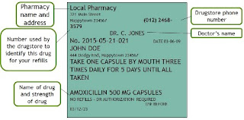](https://1.bp.blogspot.com/-4S-XzllWMTA/X4j57zTI11I/AAAAAAAAFZk/osTdqqWkctoRpkTEpt81jHAYLCILgcHpQCLcBGAsYHQ/s448/contoh%2Blabel%2Bobat%2B1.webp)